**Customizable Dictionary**

Quick-Insert-Export Dictionary Data Engine

Segundo, Julian Caleb D.

Computer Engineering-CPE21S2-1910512

CPE Department, TIP Manila

Manila, Philippines

juliancalebsegundo@gmail.com

Volante, Barron Joshua B.

Computer Engineering-CPE21S2-1910871

CPE Department, TIP Manila

Cavite, Philippines

volantebjb@gmail.com

*Abstract*— The Customizable Dictionary is a dictionary that allows the full customization by a user. The full customization allows the user to define certain jargons or document new words on-the-go; it also opens the possibility of rapid lingual documentation during tribal (or similar) immersion. The program is written in Python 3 (guaranteed compatible 3.5 and above), thus it can be easily employed on a number of operating systems, including mobile; the user interface, within the Python Command-line Interface (PyCLI), ensures the most minimal computing requirements.

The Customizable Dictionary features its own data engine, the Quick-Insert-Export (QIE) Customizable Dictionary Data Engine. The engine offers a handful of features, primarily being based on Quick Sort, its main feature is a powerful and high-speed data searching and sorting. Its exporting power also allows the portability of dictionary data, allowing the use of dictionary data across numerous platforms, as long as the platform has the program in the system.

The Customizable Dictionary is designed to process customized dictionary data, exuding both power and speed using a custom data engine. Being built on Python, it is highly portable and able to run numerous platforms; the dictionary data can be used in any of these platforms. The dictionary opens numerous possibilities ranging from personal to professional to research use, as long as the matter is related to linguistics or languages.

*Keywords*—

# Introduction

The idea of the Customizable Dictionary derives from Quick Sort’s original purpose, a dictionary sorting algorithm [5]. In lieu to this, the idea itself is self-explanatory, a fully-customizable dictionary by a user. It will, therefore, take advantage of Quick Sort at its core, considering the possible scale of data to be stored.

The Customizable Dictionary will be designed to efficiently insert-sort-search through the large-scale data in the dictionary, employing primarily a Quick Sort sorting algorithm and modified versions of Binary Search searching algorithm and Insertion Sort insertion-sorting algorithm. The algorithmic modification is made to fit the context of sorted data space beforehand by Quick Sort. In this matter, the are designed to have to have Quick Sort at its center.

In note, the Customizable Dictionary’s intended consumer is the general public, opening the public to the sorting power

brought by Quicksort. It will be designed to be more of a general public use instead of only serving a specific demographic. However, its consumer base can be limited to individuals who will be encountering jargons and nouveau words on a common basis and the linguistics fields.

# Quick Sort Algorithm

The Quick Sort algorithm is a successor to Insertion Sort, in terms of speed and data efficiency, designed for large-scale data [1]. Quick Sort, being an in-place sorting algorithm, it requires no additional memory space, making it more efficiency in data handling than similar sorting algorithms that require additional memory space. Moreover, the divide-and-conquer design also allows multithreading, therefore the possibility of having lower run time than other sorting algorithms significantly [2]–[4]. However, these same strengths also make Quick Sort, or other large-scale sorting algorithm rare in massive consumption, as there is rarely minimal data to be sorted by the mass consumer population.

# Binary Chop Algorithm

The “Binary Chop” algorithm, known as the Binary Search, is a searching algorithm designed, traditionally, for sorted data spaces [6], [7]. The centroids of data is the point-of-comparison of the algorithm, therefore, having an almost similar logic to a divide-and-conquer algorithm. This makes it most suitable for this use, given the context of pre-sorted data, to minimize search times, in any data context, in comparison to linear sort [6], [8].

# Insertion Sort Algorithm

The Insertion Sort algorithm may seem to be an overkill or overuse of sorting power. However, in this case, it will be not necessarily used as a sorting utility, instead, it is an entry-insertion utility [1], [9]–[11]. It would be modified, in sense that it is in idea still Insertion Sort but having more of Quick Sort’s algorithm logic. This method would reduce sorted insertion run times, instead of insert-then-sort methods, taking more advantage of the Quick Sort’s speed while also reducing its instability [1], [9], [11]–[14].

# Ease of Use

## Selecting a Template (Heading 2)

First, confirm that you have the correct template for your paper size. This template has been tailored for output on the US-letter paper size. If you are using A4-sized paper, please close this template and download the file for A4 paper format called “CPS_A4_format”.

## Maintaining the Integrity of the Specifications

The template is used to format your paper and style the text. All margins, column widths, line spaces, and text fonts are prescribed; please do not alter them. You may note peculiarities. For example, the head margin in this template measures proportionately more than is customary. This measurement and others are deliberate, using specifications that anticipate your paper as one part of the entire proceedings, and not as an independent document. Please do not revise any of the current designations.

# Prepare Your Paper Before Styling

Before you begin to format your paper, first write and save the content as a separate text file. Keep your text and graphic files separate until after the text has been formatted and styled. Do not use hard tabs, and limit use of hard returns to only one return at the end of a paragraph. Do not add any kind of pagination anywhere in the paper. Do not number text heads-the template will do that for you.

Finally, complete content and organizational editing before formatting. Please take note of the following items when proofreading spelling and grammar:

## Abbreviations and Acronyms

Define abbreviations and acronyms the first time they are used in the text, even after they have been defined in the abstract. Abbreviations such as ASME, SI, MKS, CGS, sc, dc, and rms do not have to be defined. Do not use abbreviations in the title or heads unless they are unavoidable.

## Units

* Use either SI (MKS) or CGS as primary units. (SI units are encouraged.) English units may be used as secondary units (in parentheses). An exception would be the use of English units as identifiers in trade, such as “3.5-inch disk drive”.
* Avoid combining SI and CGS units, such as current in amperes and magnetic field in oersteds. This often leads to confusion because equations do not balance dimensionally. If you must use mixed units, clearly state the units for each quantity that you use in an equation.
* Do not mix complete spellings and abbreviations of units: “Wb/m2” or “webers per square meter”, not “webers/m2”. Spell out units when they appear in text: “. . . a few henries”, not “. . . a few H”.
* Use a zero before decimal points: “0.25”, not “.25”.

## Equations

The equations are an exception to the prescribed specifications of this template. You will need to determine whether or not your equation should be typed using either the Times New Roman or the Symbol font (please no other font). To create multileveled equations, it may be necessary to treat the equation as a graphic and insert it into the text after your paper is styled.

Number equations consecutively. Equation numbers, within parentheses, are to position flush right, as in (1), using a right tab stop. To make your equations more compact, you may use the solidus ( / ), the exp function, or appropriate exponents. Italicize Roman symbols for quantities and variables, but not Greek symbols. Use a long dash rather than a hyphen for a minus sign. Punctuate equations with commas or periods when they are part of a sentence, as in

       

Note that the equation is centered using a center tab stop. Be sure that the symbols in your equation have been defined before or immediately following the equation. Use “(1)”, not “Eq. (1)” or “equation (1)”, except at the beginning of a sentence: “Equation (1) is . . .”

## Some Common Mistakes

* The word “data” is plural, not singular.
* The subscript for the permeability of vacuum **0, and other common scientific constants, is zero with subscript formatting, not a lowercase letter “o”.
* In American English, commas, semi-/colons, periods, question and exclamation marks are located within quotation marks only when a complete thought or name is cited, such as a title or full quotation. When quotation marks are used, instead of a bold or italic typeface, to highlight a word or phrase, punctuation should appear outside of the quotation marks. A parenthetical phrase or statement at the end of a sentence is punctuated outside of the closing parenthesis (like this). (A parenthetical sentence is punctuated within the parentheses.)
* A graph within a graph is an “inset”, not an “insert”. The word alternatively is preferred to the word “alternately” (unless you really mean something that alternates).
* Do not use the word “essentially” to mean “approximately” or “effectively”.
* In your paper title, if the words “that uses” can accurately replace the word “using”, capitalize the “u”; if not, keep using lower-cased.
* Be aware of the different meanings of the homophones “affect” and “effect”, “complement” and “compliment”, “discreet” and “discrete”, “principal” and “principle”.
* Do not confuse “imply” and “infer”.
* The prefix “non” is not a word; it should be joined to the word it modifies, usually without a hyphen.
* There is no period after the “et” in the Latin abbreviation “et al.”.
* The abbreviation “i.e.” means “that is”, and the abbreviation “e.g.” means “for example”.

An excellent style manual for science writers is [7].

# Using the Template

After the text edit has been completed, the paper is ready for the template. Duplicate the template file by using the Save As command, and use the naming convention prescribed by your conference for the name of your paper. In this newly created file, highlight all of the contents and import your prepared text file. You are now ready to style your paper.

## Authors and Affiliations

The template is designed so that author affiliations are not repeated each time for multiple authors of the same affiliation. Please keep your affiliations as succinct as possible (for example, do not differentiate among departments of the same organization). This template was designed for two affiliations.

### For author/s of only one affiliation (Heading 3): To change the default, adjust the template as follows.

#### Selection (Heading 4): Highlight all author and affiliation lines.

#### Change number of columns: Select Format > Columns >Presets > One Column.

#### Deletion: Delete the author and affiliation lines for the second affiliation.

#### For author/s of more than two affiliations: To change the default, adjust the template as follows.

#### Selection: Highlight all author and affiliation lines.

#### Change number of columns: Select Format > Columns > Presets > One Column.

#### Highlight author and affiliation lines of affiliation 1 and copy this selection.

#### Formatting: Insert one hard return immediately after the last character of the last affiliation line. Then paste the copy of affiliation 1. Repeat as necessary for each additional affiliation.

#### Reassign number of columns: Place your cursor to the right of the last character of the last affiliation line of an even numbered affiliation (e.g., if there are five affiliations, place your cursor at end of fourth affiliation). Drag the cursor up to highlight all of the above author and affiliation lines. Go to Format > Columns and select “2 Columns”. If you have an odd number of affiliations, the final affiliation will be centered on the page; all previous will be in two columns.

## Identify the Headings

Headings, or heads, are organizational devices that guide the reader through your paper. There are two types: component heads and text heads.

Component heads identify the different components of your paper and are not topically subordinate to each other. Examples include Acknowledgments and References and, for these, the correct style to use is “Heading 5”. Use “figure caption” for your Figure captions, and “table head” for your table title. Run-in heads, such as “Abstract”, will require you to apply a style (in this case, italic) in addition to the style provided by the drop down menu to differentiate the head from the text.

Text heads organize the topics on a relational, hierarchical basis. For example, the paper title is the primary text head because all subsequent material relates and elaborates on this one topic. If there are two or more sub-topics, the next level head (uppercase Roman numerals) should be used and, conversely, if there are not at least two sub-topics, then no subheads should be introduced. Styles named “Heading 1”, “Heading 2”, “Heading 3”, and “Heading 4” are prescribed.

## Figures and Tables

### Positioning Figures and Tables: Place figures and tables at the top and bottom of columns. Avoid placing them in the middle of columns. Large figures and tables may span across both columns. Figure captions should be below the figures; table heads should appear above the tables. Insert figures and tables after they are cited in the text. Use the abbreviation “Fig. 1”, even at the beginning of a sentence.

1. Table Type Styles

| Table Head | Table Column Head | | |
| --- | --- | --- | --- |
| Table column subhead | Subhead | Subhead |
| copy | More table copya |  |  |

a. Sample of a Table footnote. (Table footnote)

We suggest that you use a text box to insert a graphic (ideally 300 dpi), with all fonts embedded) because, in an MSW document, this method is somewhat more stable than directly inserting a picture.

To have non-visible rules on your frame, use the MSWord pull-down menu, select Format > Borders and Shading > Select “None”.

1. Example of a ONE-COLUMN figure caption.

Please see last page of this document for AN EXAMPLE of a 2-COLUMN Figure.

Figure Labels: Use 8 point Times New Roman for Figure labels. Use words rather than symbols or abbreviations when writing Figure axis labels to avoid confusing the reader. As an example, write the quantity “Magnetization”, or “Magnetization, M”, not just “M”. If including units in the label, present them within parentheses. Do not label axes only with units. In the example, write “Magnetization (A/m)” or “Magnetization {A[m(1)]}”, not just “A/m”. Do not label axes with a ratio of quantities and units. For example, write “Temperature (K)”, not “Temperature/K”.

## Footnotes

Use footnotes sparingly (or not at all) and place them at the bottom of the column on the page on which they are referenced. Use Times 8-point type, single-spaced. To help your readers, avoid using footnotes altogether and include necessary peripheral observations in the text (within parentheses, if you prefer, as in this sentence).

# Copyright Forms and Reprint Orders

You must submit the ASME Electronic Copyright Form (ECF) per Step 7 of the CPS author kit’s web page. THIS FORM MUST BE SUBMITTED IN ORDER TO PUBLISH YOUR PAPER.

Please see Step 9 for ordering reprints of your paper. Reprints may be ordered using the form provided as <reprint.doc> or <reprint.pdf>.

##### Acknowledgment

The preferred spelling of the word “acknowledgment” in America is without an “e” after the “g”. Avoid the stilted expression, “One of us (R.B.G.) thanks . . .” Instead, try   
“R.B.G. thanks”. Put applicable sponsor acknowledgments here; DO NOT place them on the first page of your paper or as a footnote.

##### References

1. [1] C. A. R. Hoare, “Algorithm 64: Quicksort,” Commun. ACM, vol. 4, no. 7, p. 321, 1961, doi: 10.1145/366622.366644.
2. [2] P. Sanders and T. Hansch, “Efficient massively parallel quicksort,” Lect. Notes Comput. Sci. (including Subser. Lect. Notes Artif. Intell. Lect. Notes Bioinformatics), vol. 1253, pp. 13–24, 1997, doi: 10.1007/3-540-63138-0_2.
3. [3] R. S. Francis and L. J. H. Pannan, “A parallel partition for enhanced parallel QuickSort,” Parallel Comput., vol. 18, no. 5, pp. 543–550, 1992, doi: 10.1016/0167-8191(92)90089-P.
4. [4] P. Tsigas and Y. Zhang, “A simple, fast parallel implementation of Quicksort and its performance evaluation on SUN Enterprise 10000,” Proc. - 11th Euromicro Conf. Parallel, Distrib. Network-Based  
   Process. Euro-PDP 2003, pp. 372–381, 2003, doi: 10.1109/EMPDP.2003.1183613.
5. [5] S. U.-S. of E.-C. S. Department,   
   “Tony Hoare >> Contributions >> Quicksort.” https://cs.stanford.edu/people/eroberts/courses/soco/projects/2008-09/tony-hoare/quicksort.html (accessed Oct. 30, 2020).
6. [6] A. B. Almostafa, “Maximum-speed search Algorithm,” 2018 6th Int. Conf. Control Eng. Inf. Technol. CEIT 2018, no. October, pp. 1–6, 2018, doi: 10.1109/CEIT.2018.8751856.
7. [7] A. Hatamlou, “In search of optimal centroids on data clustering using a binary search algorithm,” Pattern Recognit. Lett., vol. 33, no. 13, pp. 1756–1760, 2012, doi: 10.1016/j.patrec.2012.06.008.
8. [8] R. Nowak, “Generalized binary search,” 46th Annu. Allert. Conf. Commun. Control. Comput., pp. 568–574, 2008, doi: 10.1109/ALLERTON.2008.4797609.
9. [9] T. SinghSodhi, S. Kaur, and S. Kaur, “Enhanced Insertion Sort Algorithm,” Int. J. Comput. Appl., vol. 64, no. 21, pp. 35–39, 2013, doi: 10.5120/10761-5724.
10. [10] M. A. Bender, M. Farach-Colton, and M. A. Mosteiro, “Theory of Computing Insertion Sort Is O ( n log n ) ∗,” vol. 397, pp. 391–397, 2006.
11. [11] B. C. Dean, “A simple expected running time analysis for randomized ‘divide and conquer’ algorithms,” Discret. Appl. Math., vol. 154, no. 1, pp. 1–5, 2006, doi: 10.1016/j.dam.2005.07.005.
12. [12] D. Cederman and P. Tsigas, “GPU-Quicksort,” ACM J. Exp. Algorithmics, vol. 14, no. 1, 2009, doi: 10.1145/1498698.1564500.
13. [13] J. L. Bentley and R. Sedgewick, “Fast algorithms for sorting and searching strings,” Proc. Annu. ACM-SIAM Symp. Discret. Algorithms, pp. 360–369, 1997.
14. [14] M. H. van Emden, “Algorithms 402: Increasing the efficiency of quicksort,” Commun. ACM, vol. 13, no. 11, pp. 693–694, 1970, doi: 10.1145/362790.362803.

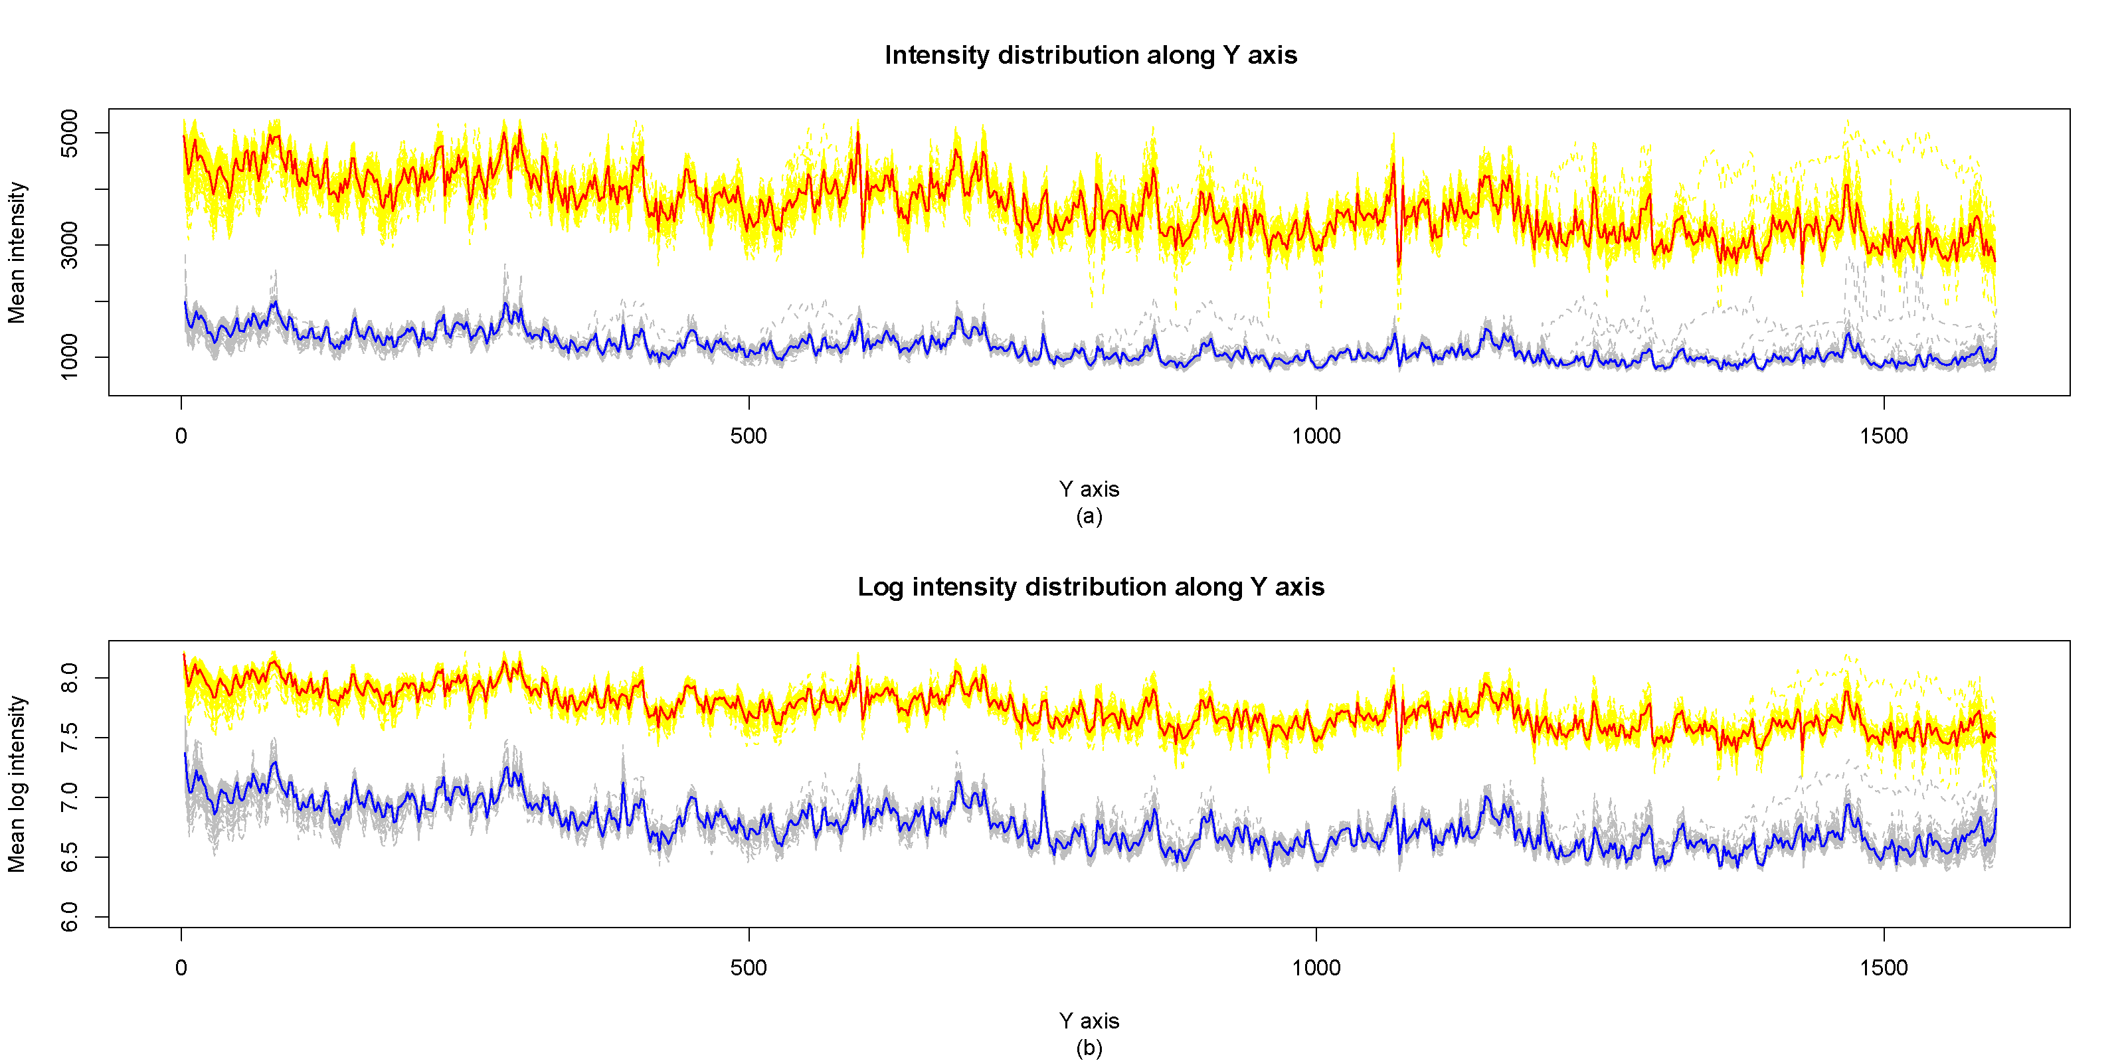 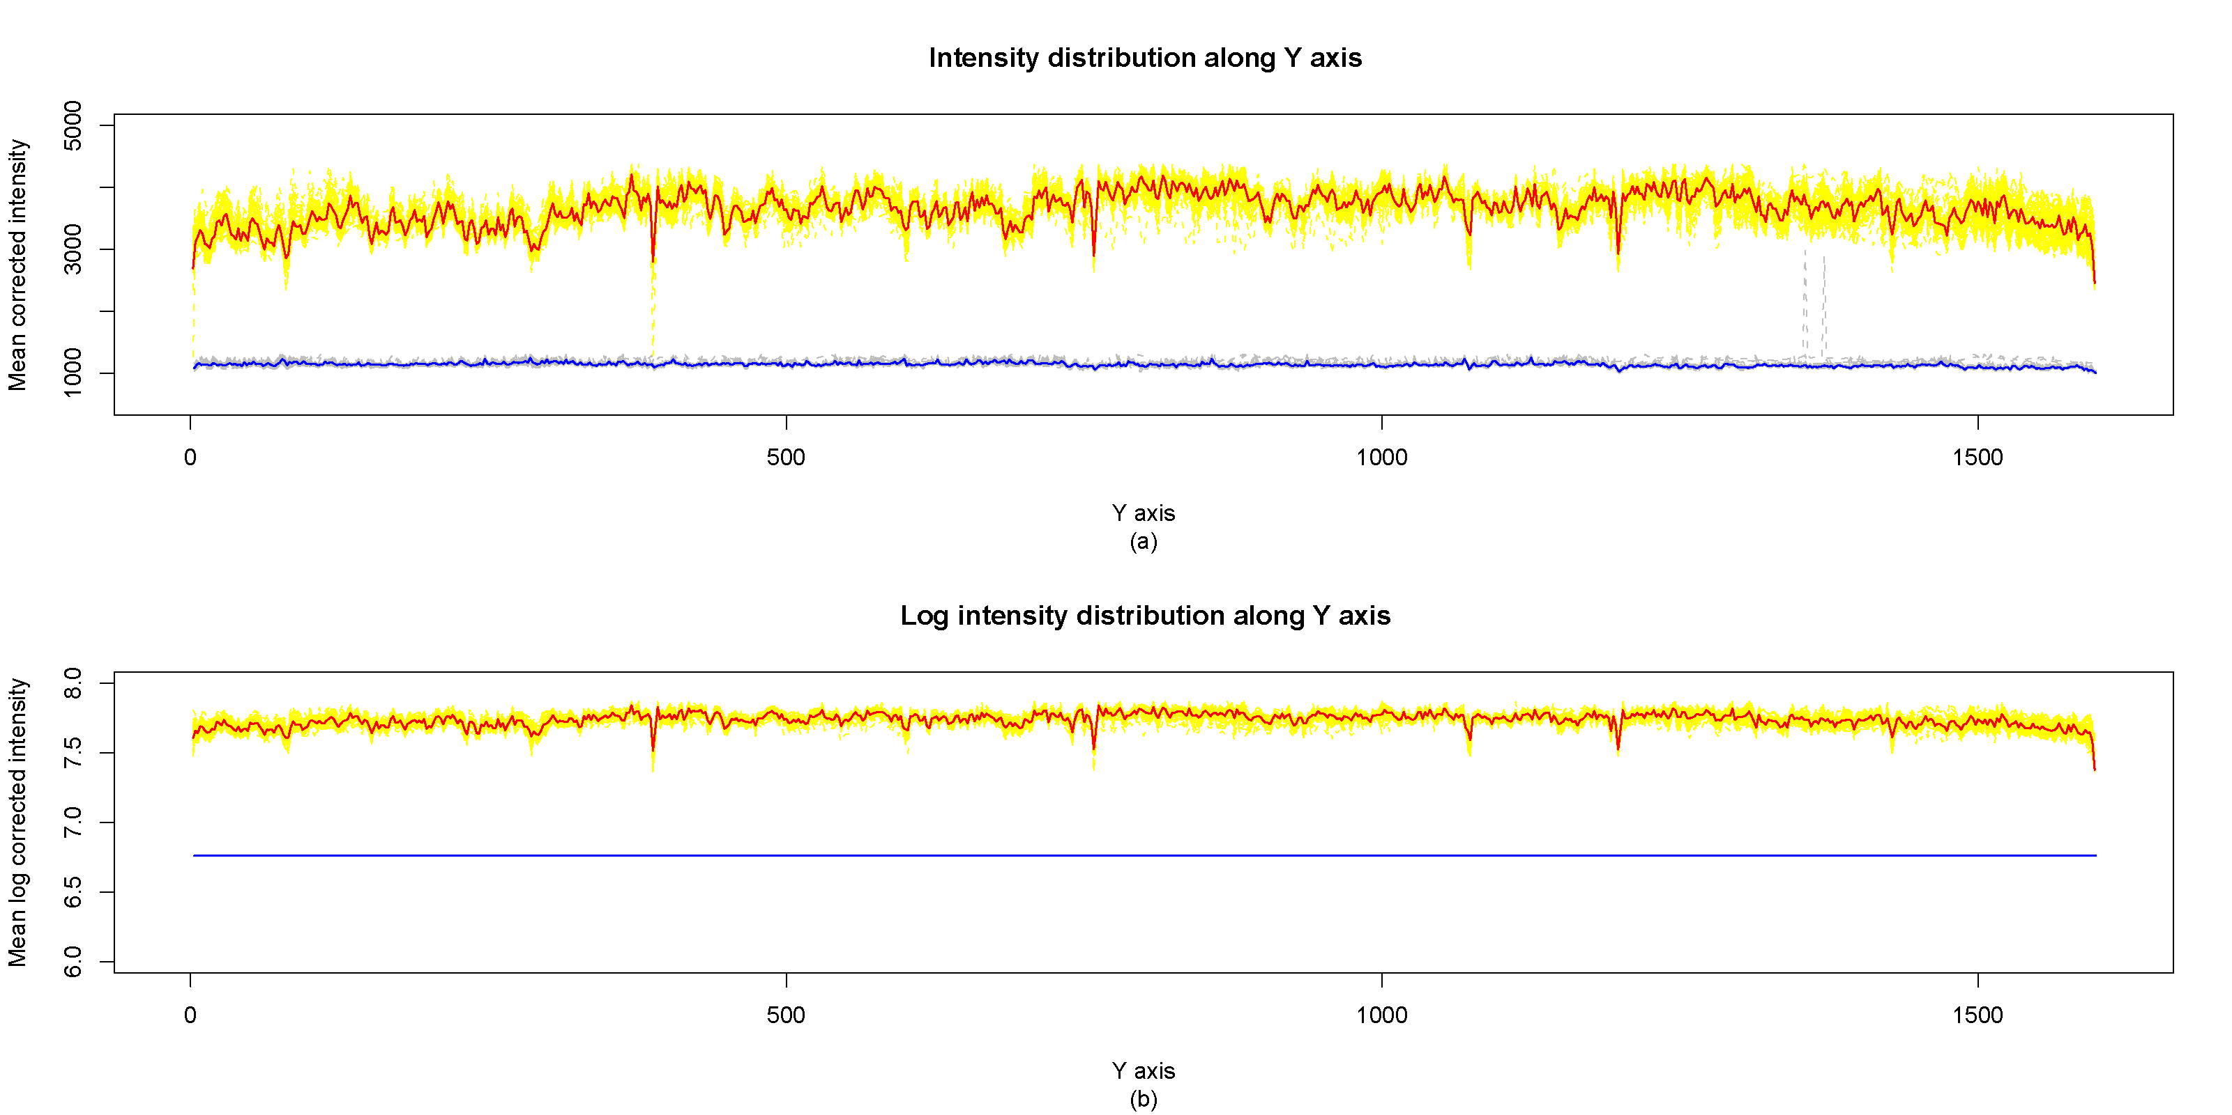

1. Example of a TWO-COLUMN figure caption: (a) this is the format for referencing parts of a figure.

##### **Authors’ background**

|  |  |  |  |
| --- | --- | --- | --- |
| Your Name | Title* | Research Field | Personal website |
|  |  |  |  |
|  |  |  |  |
|  |  |  |  |
|  |  |  |  |

*This form helps us to understand your paper better, the form itself will not be published.

*Title can be chosen from: master student, Phd candidate, assistant professor, lecture, senior lecture, associate professor, full professor